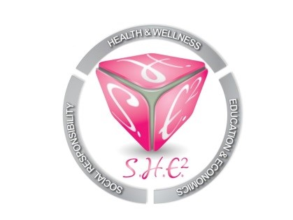
Board Meeting Minutes
November 3, 2018
3:00PM-Imani School, 12401 South Post Oak Road
Our mission is to empower and motivate women of all ages and backgrounds in the areas of Social responsibility, Health and wellness, Education and Economics. S.H.E. Squared will provide workshops, seminars, scholarships and community support to individuals and organizations that are either female driven or geared towards the advancement of women.

Start Time: 3:11PM

Present:
Carlis Lollie
Yolanda Brown
Erin Moseley
Jeffea Gullett

Excused: Lashandra Boddy

Old Business
I. Laptop Donation (Erin)- (10) laptops were donated today, November 3, 2018 at the Imani School during their annual Harvest Fest. Sharon Garner (Curriculum Coordinator) was the contact person at the Imani School. Laptops were donated to S.H.E. Squared by Boardwalk Pipelines.

II. Nurse Night @ The Museum (Carlis)- The date is scheduled for May 6th at the John P. McGovern Health Museum. S.H.E. Squared will be needed mainly for ‘hands-on’ day of activities, however, there may be instances where assistance is needed in the planning stages.

III. Christmas Party/Community Service Event (Jeffea)- The organization, Shades of Blue is excited to have S.H.E. Squared to adopt a family this year. There are no restrictions on what we can do as an organization. The family will be selected by November 10, 2018. The date for the party is tentatively scheduled for December 15, 2018.

New Business

I. Financial Statements-Account balance is $429.64. Members agreed to that as more money is generated, we can use the account for programs and activities. The Bank of America account statements for July 2018-October 2018 were passed around to present board members for review.

II. Dues- Dues are $25/per month. Board members can donate more if they wanted to. Members agreed that dues payments of $25 is sufficient.

III. Board Members Recruitment- Carlis stated she would like for S.H.E. Squared to have a minimum of (10) active and dedicated board members. If current members know of anyone who may be interested, they can let the board know. There should be a process in place to select board members.

IV. Board Member Retreat- Carlis suggested to have the retreat at Central Market on Westheimer. Erin suggested to have the retreat out of town or at a hotel in order to be productive. Erin will be the retreat coordinator and provide details at the next meeting. Retreat is scheduled for March 2019. Carlis stated that ideas for programs and projects will need to be presented at the retreat in great detail to include goals, objectives, planning, budget, etc. Erin had an idea to have a small leadership retreat before the end of 2018 at the Imani School. It was suggested to have the event at the MLK Day of Service on January 15, 2019. This project has been tabled for further review.

Meeting adjourned at 3:58PM

