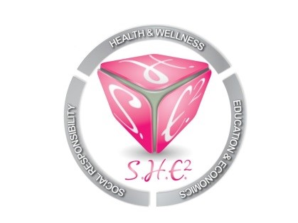
CONFERENCE CALL MINUTES
October 20, 2019
6:30PM-6:54PM
Our mission is to empower and motivate women of all ages and backgrounds in the areas of Social responsibility, Health and wellness, Education and Economics. S.H.E. Squared will provide workshops, seminars, scholarships and community support to individuals and organizations that are either female driven or geared towards the advancement of women.

Call Time: 23 minutes

Roll call:
Carlis Lollie
Yolanda Brown
Jeffea Gullett (Excused)
Erin Moseley (Not Present)

I. (October)
-Sponsor a Mammogram- May be too late to do this year. Should try to coordinate for next year.

-“Future Female Leaders Institute”-Would be beneficial to start the program outside of the school district to gauge its effectiveness. Maybe at a church or just have interested parents bring their kids on a weekend to workshops. The workshops can be held at Central Market (Free). Will consider starting the program soon.

II. (November)
“Well Diva Workshop”-November 9th- Free workshop for women where we can discuss a myriad of topics. Topics: Relationships, Finance, Inner Peace. Offer lite bites and wine. Will contact health and fitness coach, finance guru and life coach.

III. (December)
-“Miracles Home”-A proposal was made to host a white elephant gift exchange (we supply gifts and order food). Yolanda will chair and contact Miracles Home for confirmation.

“World AIDS Day”-Red Bottom Social. We can partner with another organization (preferably an HIV/AIDS group) to have a simple, yet effective event. Will wait to collaborate with Jeffea Gullett.

